My goal is to become associated with a company where I can utilize my skills and gain further experience while enhancing the company’s productivity and reputation.

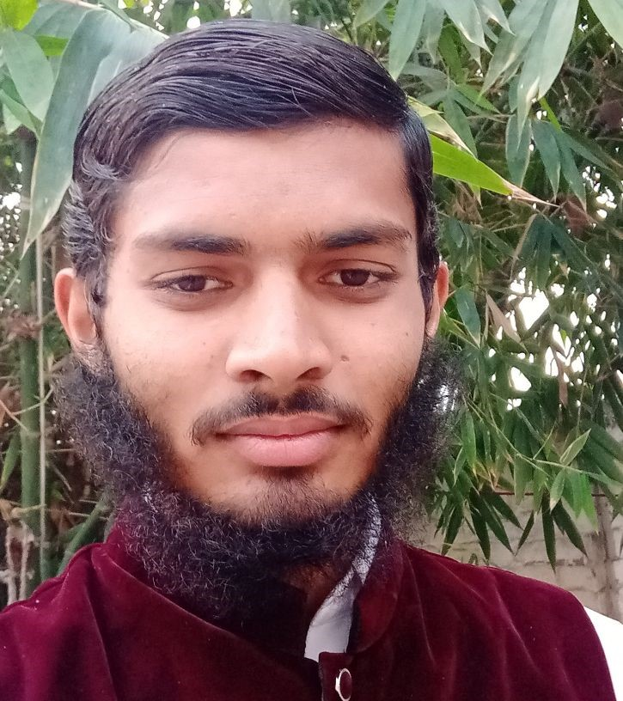

**SHAKEEL MEHMOOD**

Shahzada Village, P/O Kahna, Gajjumata, Lahore.

ashakeelahmad47@gmail.com

03004605559

Pdfpk.com

**Objective**

**Education**

**Government High School Shahzada**

Matriculation

**817**

**Government College Township 2019**

Intermediate

**552**

**Virtual University Of Pakistan 2020**

Undergraduate

**CGPA 3.2**

**Activities**

Web Development

Cyber Security

Computer Work E

ffi

ciency

Deep Learning of Computer Science

**Interests**

Programing

PHP, JAVA SCRIPT, C++, JAVA

SEO

Cloud Computing

Networking

**Skills**

Web development, Web Sur

fi

ng, Networking

Social Media Marketing, WordPress,

Email Marketing

SEO

HTML, CSS,

MS O

ffi

ce, MS PowerPoint, MS Excel,

Wordpress

Good

Negotiation & Communication

**Projects**

**Web Development**

I managed two WordPress Websites.

**Search Engine Optimization**

I learn and implement search engine optimization skill to enhance my websites

Traveling

Self Learning

**Language**

Urdu

English

**Additional Information**

Poetry

Volunteering

Reading Books

**Reference**

**Will be furnished upon request**